 | FINE ORGANIC INDUSTRIES LTD
 | APPLICATION TEST REPORT
Project Name | Dispersing Additive
Sample Name | S 9076 |  | Date Issued: 02.06.2026
Batch No | 68 |  | Completed on: 09.06.2026
Reference Standard | BYK 9076 |  | Issued by: Mr. Satish Warghude
Physical Appearance | Reference Standard |  | Amber to yellow viscous liquid
Physical Appearance | S 9076 |  | Yellow viscous liquid
Ink Resin base/Ink System: Nitrocellulose
Testing Parameter | Violet 23 |  | Violet 27
Testing Parameter | Ref Standard | S 9076 | Ref Standard | S 9076
Grinding (µm) | < 5 µm | < 5 µm | < 5 µm | < 5 µm
Colour Shade | Reference Std | As per Std | Reference Std | Bluer
Transparency | Reference Std | Slightly opaque | Reference Std | Transparent
Color Strength (%) | 100.00 | 98-99 | 100.00 | 30-40
Viscosity (B4 Cup@26°C) | 29 s | 30 s | 27 s | 29 s
Adhesion (Tape Test) | Pass | Pass | Pass | Pass
Gloss @ 60° | 67.1 | 62.2 | 8.8 | 7.9
Re-solubility (Rating) | 3 | 1 | 3 | 5
Separation | No | No | No | No
Settling | No | No | No | No
Testing Parameter | Carbon Black N 330
Testing Parameter | Ref Standard | S 9076
Grinding (µm) | < 5 µm | < 5 µm
Colour Shade | Reference Std | As per Std
Transparency | Reference Std | As per Std
Color Strength (%) | 100.00 | 100.00
Viscosity (B4 Cup@26°C) | 32 s | 33 s
Adhesion (Tape Test) | Pass | Pass
Gloss @ 60° | 41.9 | 43.6
Re-solubility (Rating) | 3 | 2
Separation | No | No
Settling | No | No
Re-solubility Rating: 1 – Fail, 2 – Poor, 3 – Average, 4 – Good, 5 – Excellent
Note: Re-solubility tested in Ethyl Acetate + Toluene (50:50).
Results: Not OK (Gloss and Colour strength inferior).
Completed By: Mr. Mohan Yadav
Authorized By: Dr. Sachin Jagtap

Re-solubility
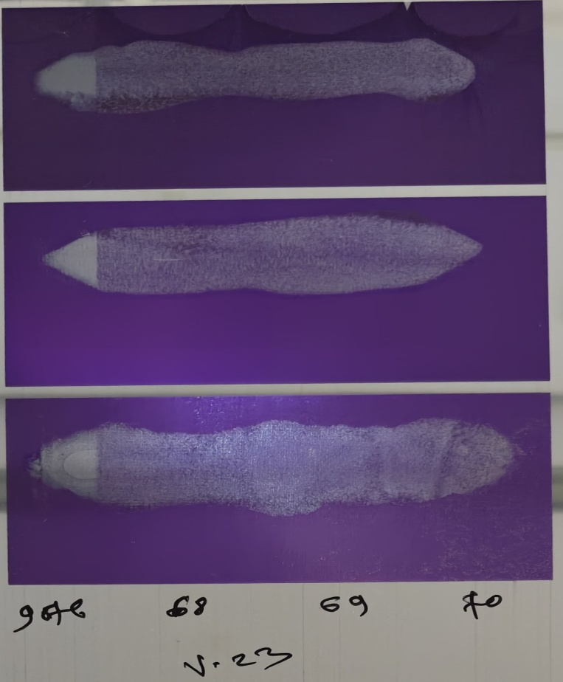 | 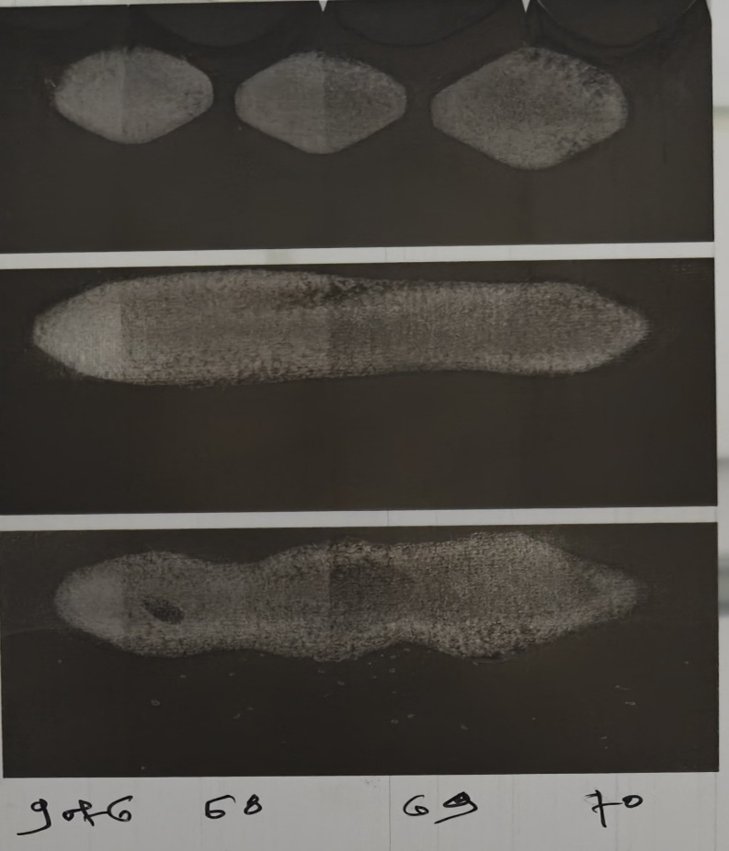
Color Strength- Violet 27


